After completing US Petition Management Approval process 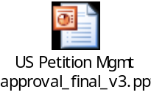please follow below steps to apply for L1 Petition. If approval process is not completed then please initiate as per guidelines outlined in above presentation.

Required Documentation

Step1
- Please forward the validated approval through Parichay Dewan to initiate L1
Process. Kindly send scan copy of final approval (do not send email approval).

Step 2
- First Step Document: Please fill out following document & send to Global
Mobility Team

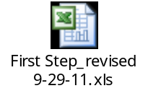
Step 3
- Employee Data Sheet: Please fill out following document & send to Global
Mobility Team



Step 4
- Upon receiving above documents Global Mobility & Immigration Team will
initiate electronic case request and make determination on visa eligibility

Step 5
- Faegre & Benson (Law Firm) will send electronic L1 Visa Questionnaire to
employee with necessary guidance and documents to be provided

Step 6
- Global Mobility & Immigration Team will send L1 Visa Questionnaire to India
Manager who inturn need to work with US Manager and provide strong
information on employee candidature and forward filled L1 Visa questionnaire to
Global Mobility & Immigration Team (samier_mahto@uhc.com). Employee need
to work with India & US Manager and ensure that L1 Visa Questionnaire
(Manager) is filled and sent to Global Mobility & Immigration Team

Step 7
- Employee need to fill electronic L1 Visa Questionnaire and upload required
documents in LawLogix Tool (as per instructions received through Faegre &
Benson team). Employee can refer to following guidance material on filling out
L1 Visa Questionnaire
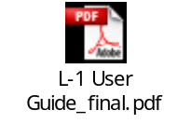

Step 8
- Upon receiving complete documents (including L1 Visa Questionnaire from
employee & managers), Faegre & Benson (Law Firm) will process the case. In
case of additional documents/information required then an attorney or
representative from Global Mobility & Immigration Team will contact employee
directly

Step 9
- For better understanding on lifecycle of overall US Petition Application process
please refer to following document


